Milestone 10: Multimedia Platform
CSCI 311 – Fall 2025

Please be sure that you complete all pages of this worksheet. Some sections may begin on new pages, so you may need to scroll past any blank space.

Background Material
These questions relate to the background reading from the milestone instructions, and they are in the same order as the reading. You do not need to write complete sentences for questions that ask for a short answer. Paragraph or bullet form is acceptable for questions that require an explanation or description.

1. To what service does FreeTube provide a private interface?

2. What application did we install to play downloaded video files?

3. What game is an open source clone of MarioKart?

4. What term means a combination of hardware and a software stack that enables execution of specific types of applications?

Please continue to the next page.

Multimedia Platform
Replace the following image with the photo specified in the milestone instructions.
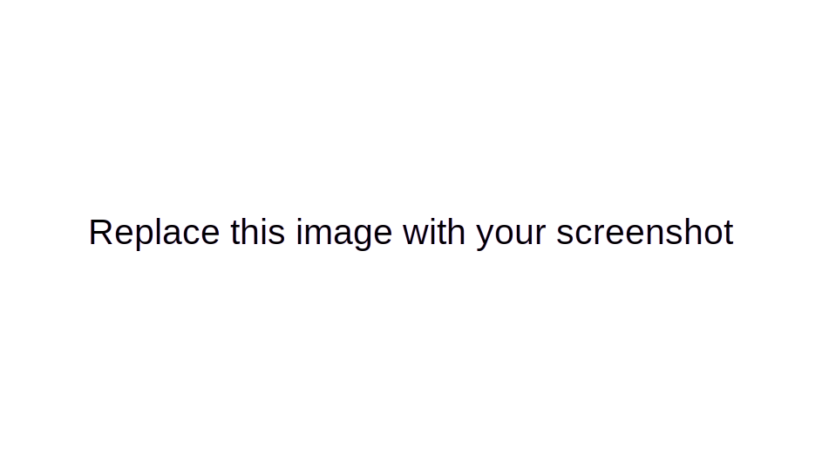

Submission
When you have completed this worksheet, export it to PDF format. Upload the PDF file as your Moodle submission for Milestone 10.

