Dr. Whalen Office Hours: as scheduled
EHFA 264 per semester and
(843) 349-2350 by appointment

Historical Theory and Methods
History 300
CASE STUDY: The Belgian Congo

This course provides an introduction to modern historical methods, theoretical considerations, and practical approaches pertinent to thinking and writing about history.

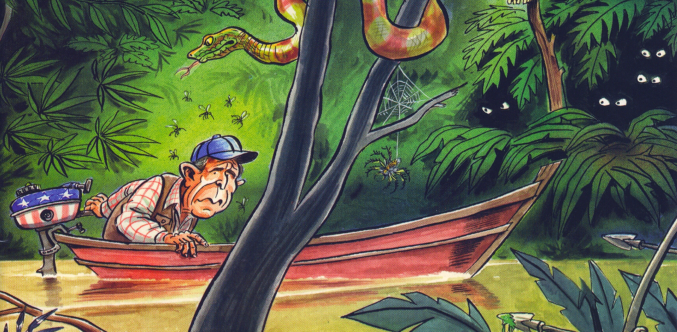

Required Texts:
J. Nealon and S. Giroux, The Theory Toolbox (Rowman & Littlefield)
John Trimble, Writing with Style (Prentice Hall, 2000)
Joseph Conrad, Heart of Darkness (Dover)
Ph. Whalen, “Historical Methods Reader”
Ph. Whalen, “The Belgian Congo: Primary Sources”

Attendance and class participation are necessary for you to learn; each student should arrive at class on time and remain the entire class period.

General Expectations. To excel in this course, you should expect to do the following:
1) Make leaning your first priority.
2) Study and prepare approximately 10 hours per week outside of class.
3) Read approximately 70-80 pages per week outside of class.
4) Attend class each day and turn in all assigned work on time.
5) Constructive and respectful participation is expected of you in class.

Written Requirements: In-class writing exercises and an assigned final research paper 12-15 pages in length.

Essay Format: all essays are to be typewritten and be formatted accordingly: 1-inch margins all around; 1 1/2 spaced, provide footnotes, use Palatino 11; Courier 10; or Times 12. Writing: you are responsible for the mechanical and organizational aspects of your essays. Assistance in all aspects of written assignments is available at the Writing Center in 208 Prince Building. Call (843) 349-2937 to set up an appointment. Late Essays- will loose one letter grade per class. This will also apply to papers returned for not properly following the formatting instructions. Also, don't forget to put your name, course number, and section number on your work. The University policy on Plagiarism is in effect.

When editing your writing, focus on these four objectives:
set the right tone
make it easy to read
cut out unnecessary language
conform to common-sense rules of grammar

Student Consultations: You are welcome to contact me at my office at any time. (The best time to reach me, however, is during my scheduled office hours). If these times are inconvenient, I would be happy to meet with you at a more agreeable time. You may contact me by phone, by email, or by leaving a note for me in my faculty mailbox

Classroom Demeanor: During class discussions or lectures refrain from distracting those around you. Behavior that contributes to a negative educational environment will not be tolerated. Grading Scale: A= 90-100; B+= 87-89; B= 80-86; C+= 77-79; C= 70-76; D+= 67-69; D= 60- 66.

Approximate Lecture Schedule: The following is a schedule of the lecture topics in the approximate order we will cover them. Bring daily reading materials to class and be prepared to discuss them. Professor Whalen retains the right to alter the syllabus and course requirements as deemed necessary.

Week 1: Wed.- Method, Theory, and Practice.
Read: Horace Miner, “Body Ritual Among the Nacirema” and Schlesinger Jr., “History and National Stupidity.”

Week 2: Mon.- Martin Luther King Jr. Holiday
Wed.- The Belgian Congo: An Overview.
Read: Cook, “King Leopold’s Congo.”

Week 3: Mon.- Subjectivity and Perspective.
Wed.- Citations, Bibliographies, and Plagiarism.
Read: Trimble, Writing with Style, ch. 1; The Theory Toolbox, chs. 3-4; and and Schempp, “Warning: Gravity is only a Theory.”

Week 4: Mon.- Heart of Darkness, Violence, and Colonial Imagination.
Wed.- Setting up Quotes and making Transitions.
Start reading Conrad, Heart of Darkness and have read, Trimble, Writing with Style, ch. 13.

Week 5: Mon.- What are History and Historiography?
Wed.- Heart of Darkness, Violence, and Colonial Imagination.
Read: The Theory Toolbox, ch. 7 and finished Conrad’s Heart of Darkness.

Week 6: Mon.- What is Culture?
Wed.- Discuss “The Force Public.”
Read: The Theory Toolbox, chs. 4- 5 and L. Gann and P. Gignan, “The Force Public.”

Week 7: Mon.- What is Ideology?
Wed.- “Civilizing Missions”?
Read: The Theory Toolbox, ch. 6; Conklin and Fletcher, "The Imperial Mission.”

Week 8: Mon.- Using J-STOR, Project MUSE and online databases.
(Colonial Ideology Essays Due today!)
Wed.- The Belgian Congo: A Re-examination.
Read: Trimble, Writing with Style, ch. 2 and 4

Week 9: Mon.- Irony and King Leopold’s Soliloquy.
Wed.- Comparing Twain and Conrad as Historical Sources.
Read: Mark Twain’s King Leopold’s Soliloquy.

Week 10: Mon.- Insider’s History: Discuss Roger Casement.
Wed.- Space and Time.
Read: The Theory Toolbox, ch. 11 and Roger Casement’s “Letter to the Congo State….”

Week 11: Mon.- Discuss George Williams.
Wed.- What Difference(s) Make?
Read: The Theory Toolbox, ch. 10 and Williams, “An Open Letter” and other documents.

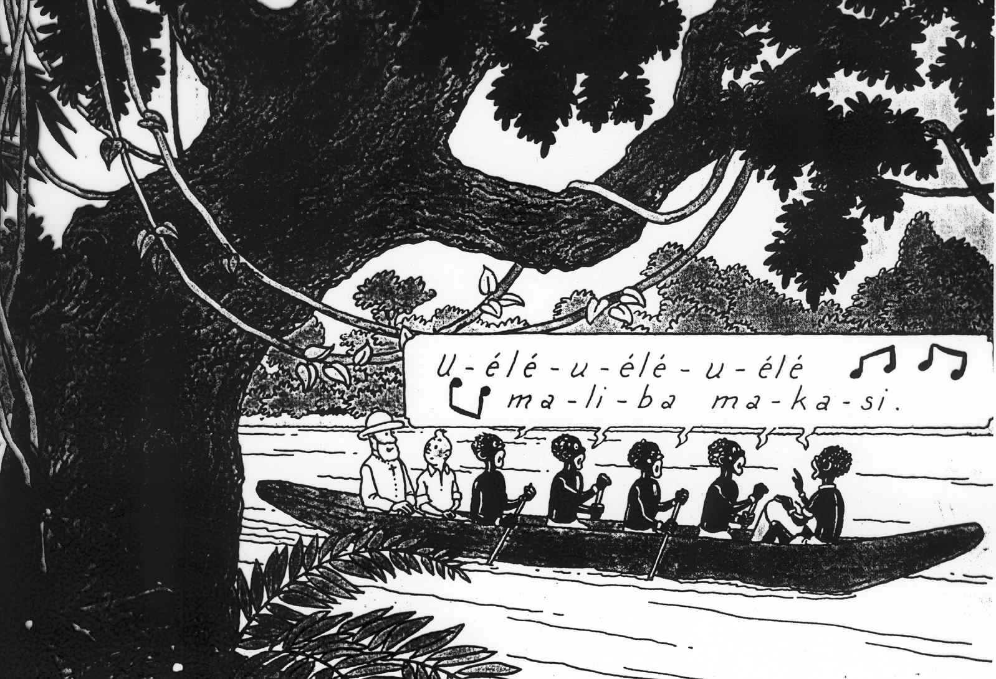

Week 12: Mon.- History for Hire: Discuss Henry Wrack.
Wed.- Writing Your Introduction.
Read: Trimble, Writing with Style, ch. 3 and Wrack, “The Story of the Free Congo.”

Week 13: Mon.- History Chastened: Discuss E. D. Morel.
Wed. Writing Your Conclusion.
Read: Trimble, Writing with Style, ch. 9 and Storey,
“Writing History Faithfully.”

Week 14: Mon.- History as Journalism.
Wed.- Discuss Hochschild.
Read: Hochschild, “Where There Aren’t No Ten Commandments” and The Theory Toolbox, ch. 11.

Week 15: Mon.- Final Research Papers due IN CLASS
The Annotated Bibliography

1. After your topic has been defined and before you begin serious reading, you should first prepare a Working Bibliography of primary and secondary sources.

2. Compile a Working Bibliography by following these steps:

A. Using J-STOR or another online index or database, locate one or more good (i.e. recent and by reputable historians) secondary sources that deal with your topic. Or find an article in an appropriate academic encyclopedia, like the Encyclopedia Britannica, which is available on-line (not a popular encyclopedia like the World Book). From either source, obtain an overview of your topic; write down facts, events, names, or questions that occur to you; these will become guides to future research. Scan the author's notes and bibliography, writing down titles that appear useful. Note if there exist bibliographic guides for your topic.

B. Using your list of facts, events, names, etc. and your bibliographic entries, go to the library: prepare a bibliography of available materials; it should include primary sources (produced during the period under consideration) and secondary sources (scholarly books and articles). A minimum of ten (20) items is required, ten (10) of which must be primary sources. The others must be books and articles in scholarly journals (like The American Historical Review or The Journal of Modern History) or Internet resources such as J-STOR or Project Muse.

Recommended Format (see Chicago manual of Style):

Twyman, Michael. Lithography 1800-1850. The Techniques of Drawing on Stone in England and France and Their Application in Works of Topography (London: Oxford University Press, 1970).

3. Locate each book or article and skim it, asking yourself: does this source help me with my topic? If not, write a note on the back of your card and save the card; if so, write a brief annotation on the card summarizing the content of the source and indicating how it will help.

4. When you have completed your search and have located the required twenty primary, secondary, and internet sources, prepare an annotated bibliography.
History 300 / Spring 2007
Dr. Whalen
Final Research Essays

To conclude this semester’s readings in historical methods and theory, you will write a 10 to 12 page (plus bibliography and footnotes) essay discussing the historical and historiographical merits of the following sources on the Belgian Congo: Conrad, Twain, L. Gann and P. Gignan, any four (4) of the Conklin and Fletcher essays, Cook, Casement, E. D. Morel, Sheppard, Williams, Wrack, Morel, Hochschild, along with your secondary sources from J-STOR, and primary sources from the N. Y. Times.

You should limit your analysis to one theme– such as representations of colonial violence, the nature and function of colonial administration, or a third topic selected in consultation with Dr. Whalen– that will best allow you to both discuss all the authors listed above.

You will also need to discuss at least two of each author’s theoretical investments: authority, ideology, subjectivity, culture, history, space/time/ and difference. These theories are developed in the Theory Toolbox.

Papers are due on the last day of scheduled class. Late papers will loose 5 points per calendar day. Remember to give proper citations throughout.

